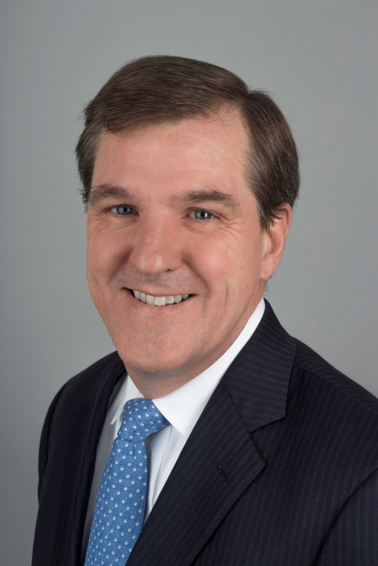
Kenneth E. F. Sands, M.D., M.P.H.
Kenneth F. Sands, M.D., M.P.H., is Chief Quality Officer and SVP, Health Care Quality at Beth Israel Deaconess Medical Center (BIDMC) and an associate professor of medicine at Harvard Medical School. He is also a member of BIDMC’s Division of General Medicine.
Dr. Sands received his medical degree from Dartmouth Medical School and his master’s degree in public health from Harvard School of Public Health. Dr. Sands’ specific expertise in infection control has led to numerous publications on the development of practical methods for monitoring hospital infections using automated datasets. Other interests relate to patient safety education and health care risk management. Dr. Sands has led a number of activities in Massachusetts to advance malpractice litigation reform, including serving as principal investigator of an AHRQ-funded study to evaluate readiness for disclosure/apology/offer models in Massachusetts, and co-founder of the Massachusetts Alliance for Communication and Resolution following Medical Injury. Dr. Sands is a co-founder and site director for the Harvard Medical School Fellowship in Clinical Quality and Patient Safety where he received the school's Commencement Achievement Award.

